Payroll Management System for Information Technology Company

Use-Case Specification: Add Working-Time

Version 1.0

Revision History

|  |  |  |  |
| --- | --- | --- | --- |
| **Date** | **Version** | **Description** | **Author** |
| 15/12/2019 | 1.0 | Final | Quản Trọng Tú |
|  |  |  |  |
|  |  |  |  |
|  |  |  |  |

Table of Contents

1. Use-Case Name 4

1.1 Brief Description 4

1.2 Actor 4

2. Flow of Events 4

2.1 Basic Flow 4

3. Special Requirements 5

4. Preconditions 5

5. Postconditions 5

6. Extension Points 5

Use-Case Specification: Adding Working-Time

# Use-Case Name

## Brief Description

This use case defines the steps of adding a working time for user who are working in company to store it in the database system. Administrator can easily add a new working time for each user and themselves.

## Actor

Administrator

# Flow of Events

## Basic Flow

The system Administrator enter the user id and click search to find out the information of user and know their time was declared or wasn’t declared. If their working-time was not created, the administrator will perform adding working-time function. The administrator sets database management parameter that holds working-time information that has just added. The system will display the new value in the table.

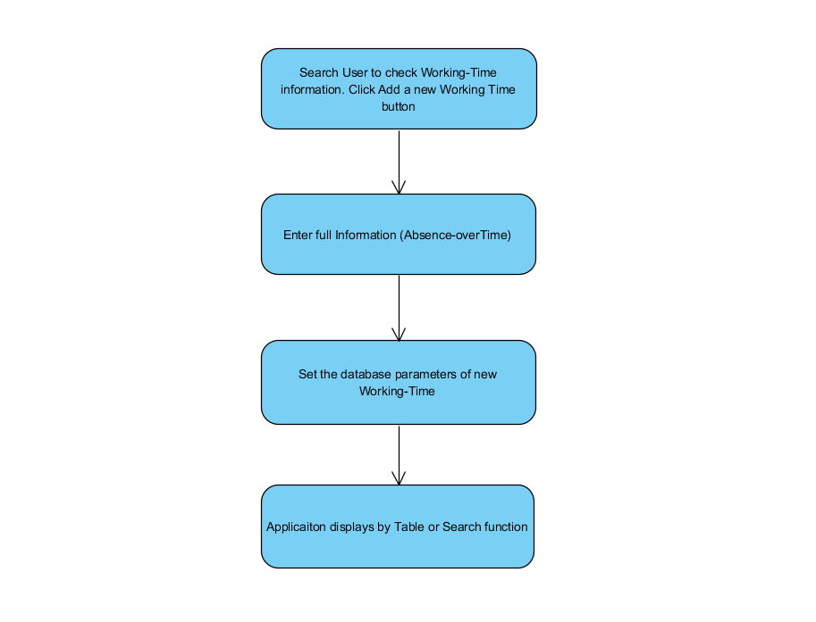

Basic Flow of Adding Working Time

# Special Requirements

* Administrator has basic knowledge of manipulating the database and know how database inputs successfully.
* Administrator need to input correctly constraint.

# Preconditions

* Administrator have to login into application and access Manage Working-Time view.
* If the user was created Working Time before, the administrator can’t initialize a new Working-Time for this user. In this case, the administrator will perform updating Working-Time function.

# Postconditions

The Message was return message if its failure or success.

# Extension Points

The administrator checks the database and application to ensure that the user is added Working-Time.